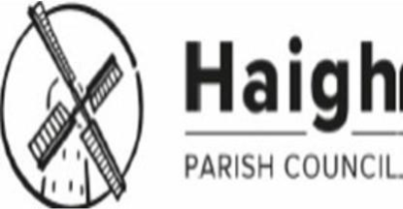
CONFIRMED
FULL Council
Minutes of the meeting held on Monday, 1st Sept 2025 at 7:00pm
St David’s Parish Rooms, Copperas Lane, Haigh
PRESENT: Councillor Paul Kenyon (Chair)
Councillor Marie-Clare Kenyon
Councillor Kerry Whittle
Councillor Jill Ingram
IN ATTENDANCE: n/a
OBSERVERS: No members of the public in attendance
HPC 49 25 ORDER OF BUSINESS:
It was agreed that the order of the published agenda be amended to bring forward the item concerning the resignation of the Parish Clerk.
HPC 50 25 RESIGNATION OF PARISH CLERK
Council formally recorded that the Clerk and Responsible Financial Officer, Mrs Dianne Scambler, had tendered her resignation with immediate effect. The resignation was accepted, and Council placed on record its appreciation of her service to Haigh Parish Council. A vacancy for the post of Clerk and Responsible Financial Officer (RFO) was declared.
HPC 51 25 TEMPORARY APPOINTMENTS
Pending recruitment of a new Clerk and RFO, the following temporary arrangements were approved:
Proper Officer: Cllr Paul Kenyon (Chair)
Responsible Financial Officer: Cllr Jill Ingram (Vice-Chair) Minute Taker for this meeting: Cllr Kerry Whittle
HPC 52 25 BANKING AND FINANCIAL SERVICES
It was noted that the Council’s bank account remains authorised and active. It was agreed that the account contact details be updated to reflect the interim appointments and the resignation of the former Clerk and RFO.
HPC 53 25 RECRUITMENT OF CLERK AND RFO
Council resolved that a recruitment pack be drafted for consideration and approval at the next Full Council meeting on Monday 27 October 2025. The pack will follow guidance from the NALC and LALC models for small councils.
HPC 54 25 LOCUM CLERK ADVICE
It was agreed that LALC and Wigan Council Democratic Services be contacted for advice on appointing a temporary locum Clerk and on the process for recruiting a permanent postholder.
HPC 55 25 PUBLIC NOTICE
Council agreed that a short statement be published on the Parish Council website confirming: the resignation of the Clerk; the interim arrangements in place; and current contact details for correspondence.
HPC 56 25 CONTINUATION OF BUSINESS
Following agreement of the above interim measures, the meeting proceeded in line with the published agenda.
HPC 57 25 APOLOGIES FOR ABSENCE Apologies for absence were received from Cllr Andrew Wilson.
The meeting was confirmed as quorate.
HPC 58 25 DECLARATIONS OF INTEREST None.
HPC 59 25 MINUTES OF THE PREVIOUS MEETING
The minutes of the meeting held on Monday 7th July 2025 were approved with minor amendments as a correct record for signing by the Chair.
HPC 60 25 MATTERS INTRODUCED BY MEMBERS OF THE PUBLIC
(a) No matters raised.
COUNCIL BUSINESS HPC 61 25 CLERKS REPORT
Further to the resignation recorded above, the Clerk’s handover documents had been received to assist the incoming officer and the Council. No additional report was presented.
HPC 62 25 GOVERNANCE REVIEWS
Several governance documents (Standing Orders, Financial Regulations, Code of Conduct, Risk Schedule, Social Media Policy, Privacy Notice, and Data Protection Policy) were presented following the internal auditor’s recommendations. With only three members present, and given the importance of these items, approval was deferred to allow all Councillors to review them before formal adoption and publication on the Council’s website.
RESOLVED That the governance documents be circulated to all Council members for review and comment by Friday, 26th September 2025, and subsequently presented for approval at the October Council meeting.
HPC 63 25 PROTOCOLS FOR HAIGH PARISH COUNCILLORS AND CLERK
Council discussed protocols to support effective communication, decision-making, and correspondence handling within Haigh Parish Council. It was agreed that the protocols document should be adopted for parish councillors, and that a complementary protocol for the Clerk’s role should also be drafted to ensure consistency of procedures and expectations. Cllr Whittle will prepare a draft document for consideration at the next Council meeting and will consult IT support regarding the establishment of a GDPR-compliant shared Google Drive for secure document management.
HPC 64 25 FINANCE
The Council received several key documents relating banking arrangements, authorisation of Payments, Payroll update.
Following the resignation of the Clerk and responsible officer, it was agreed to remove DS from the bank as a Bankline user.
Councillor J Ingram will make necessary arrangement to update the banking mandates from three signatories to two.
It was discussed to review the need for additional bank signatories to be added to the mandate and also to review the need for additional Bankline users for authorising payments Cllr Ingram to investigate and submit proposal for next meeting.
It was agreed that Haigh Parish Council will continue with the current payroll provider
HPC 65 25 PLANNING REPORT
No objections or comments raised regarding recent planning applications.
HPC 66 25 COUNCILLOR RESIGNATION / VACANCY PROCESS
The council has received formal resignation from Councillor Croston,
Chair Councillor P Kenyon will discuss with LALC and democratic services and the Returning Officer at Wigan Council, the process for recruitment and co-opt / election of new Councillors. Currently there are 2 Councillors vacancies.
Chair Councillor P Kenyon will review and discuss the interim recruitment of a Clerk and responsible financial officer, proposal to be submitted at next meeting.
HPC 67 25 FINANCIAL MATTERS
(a) PAYMENTS
The Council approved the following payments made since the last meeting:
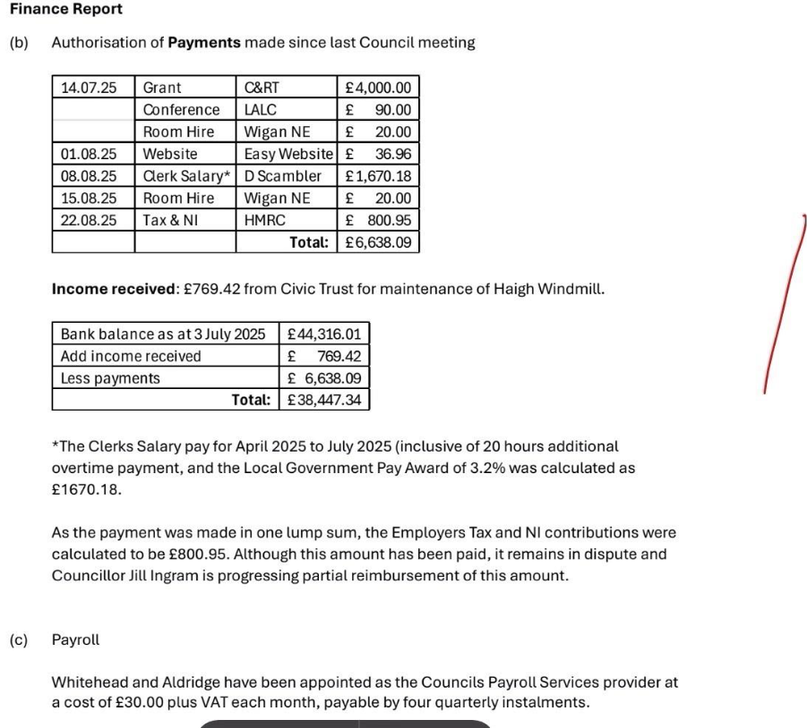
HPC 68 25 COUNCILLOR EMAILS: The creation of new Councillor emails has commenced, any outstanding emails will be processed.
HPC 69 25 ELECTION OF VICE-CHAIR It was agreed that Councillor Jill Ingram is elected Vice Chair for Haigh Parish Council.
HPC 70 25 AUDIT, GOVERNANCE AND STANDARDS COMMITTEE
Councillor Whittle was unable to attend the July meeting, but papers where shared in advance of the meeting for comment.
Councillor Whittle will attend the next Audit and Governance and Standard committee in Sept and report back to the next Haigh Parish council meeting in October.
Councillor Whittle would share future agendas with Council members for their comments ahead of future meetings.
HPC 71 25 HAIGH TRANSFORMATION – COMMUNITY PROGRAMME
Councillor were invited by Lindsey Carrington to participate in the Haigh Hall community Programme, it was agreed to invite Lindsey to the next Council meeting to understand what the community programme is about and how Haigh Parish Councillors and the community can get involved.
HPC 72 25 MEETING DATES FOR 2025
It was proposed that the Haigh Parish Council meeting be held on the First Monday of every other month. (Bi Monthly)
27th October 2025 next meeting 1st December 2025 Date for 2026 will be discussed at the next meeting.
HPC 73 25 COUNCILLOR UPDATES
- Hall Lane – Parking Proposals
Following significant emails and enquires from local residents and users of Hall Lane and Lady Mabel woods, and a meeting with Wigan Council to discuss concerns raised and the lack of consultation and engagement by Wigan Council with Haigh Parish Council , it is confirmed that the Double Yellow lines will now be suspended, pending further and wider consultation.
- Canal towpath works.
Work on the project has now recommenced. A further grant of £4000 has been paid to Canal and Rivers trust. Following a recent meeting with Wigan Council it was agreed on completion of the works to hold a press release with all those that have worked and contributed to the success of the towpath upgrades.
- Haigh Windmill
It was proposed to create a working group for Haigh Windmill, Councillor Jill Ingram will lead on the working group and awaits an invite from Peter Hughes who will set up the group to support.
- Bridleway access
It was noted following the meeting with Wigan Council that the working group be reformed Councillor M C Kenyon will lead along with Councillor P Kenyon, further support for the working group will be requested from newly appointed Councillors.
- Community engagement
Arrangement would be made to establish a working group. Councillor P Kenyon will consult with Lindsey Carrington and invite her to the next Haigh Parish council meeting to discuss the project.

HPC 74 25 Any other business Risk Register – it was agreed to defer this until the next meeting.
The meeting closed at 9.15pm.

